

**Modern CI/ CD Implementation on FlashBlade**

Contents

Document Change Tracking 5

Notes on this Document 6

Executive Summary 7

Audience 7

Heading 1 7

Heading 2 7

Heading 3 7

Modern CI/ CD using Flashblade 7

Traditional CI/ CD 7

Modern CI/ CD 7

Implementation approach 7

Kubernetes Cluster Setup 7

Kubeadm – Pre-requisites 7

Firewall should be disabled, or certain ports should be open 7

Swap disabled on the master and worker nodes 8

Install Docker 17.03+ 8

Install Kubeadm, kubelet and kubectl 9

Configure cgroup driver 9

Master Setup 10

Nodes Setup 11

Kubernetes - Configuration 11

Web Dashboard 11

Service Account / Access setup 11

Flashblade Driver 11

Heapster 11

Helm 11

Nginx Ingress 11

EFK 11

Prometheus 11

CI/ CD Tools Installation 11

Namespace 11

Nexus Artifactory 12

• Upload Build Artifacts 12

• Push Docker Images 12

Jenkins 12

Gitlab 12

Kafka 13

JIRA 14

Elasticsearch 14

CI/ CD Tools Setup 14

Nexus setup 14

Gitlab setup 14

Jenkins setup 14

Jenkins Workflow: 14

CI/ CD Pipeline execution 15

Manual run 15

Scripts 15

References 16

About the Authors 16

# Document Change Tracking

|  |  |
| --- | --- |
| Version | Changes |
| June 10, 2018 | * First revision |
| June 25, 2018 | * Updated it for Kubernetes HA cluster |
| August 20,2018 | * Configuration for Services |

# Notes on this Document

When you see this box, a best practice or important notice is defined. This might be a requirement or a recommendation—whichever one it is will be indicated in the box text:

|  |  |
| --- | --- |
|  | BEST PRACTICE: Enable a setting |

When something needs to be noted that if missed can cause data loss, corruption, data unavailability, or simply something generally important that isn’t best practice related, this box will be used to stress it:

|  |  |
| --- | --- |
|  | Please read—this is a critical note!! |

As always refer to the checklist and the document change section for important updates quickly.

# Executive Summary

TBD

# Audience

TBD

As always, for specific questions or requests for assistance, please reach out to Pure Storage support at any time at [support@purestorage.com](mailto:support@purestorage.com).

# Heading 1

## Heading 2

### Heading 3

Heading 4

# Modern CI/ CD using Flashblade

## Traditional CI/ CD

## Modern CI/ CD

## Implementation approach

# Kubernetes Cluster Setup

Before we begin setting up our CI/ CD pipelines, we have to setup our Kubernetes cluster up and running.

First, we have to ensure that the setup machine has following installed on it

* Git client
* Ansible v2.4+

Checkout the code from https://github.com/PureStorage-OpenConnect/DORAScripts.git

* cd kube-ansible
* Modify inventory files to point to correct IPs for master, nodes and etcd nodes and the ssh key for accessing the servers.

|  |  |
| --- | --- |
|  | Please ensure that you password-less access enabled to all the servers/ nodes and the key is available on setup node. |

Run ‘ansible-playbook -i inventory cluster.yml`­

* This will configure a HA Kubernetes cluster on the nodes mentioned in the inventory file.
* Copy kubernetes config from any master on your machine to access the cluster using kubectl.

# Kubernetes - Configuration

## Web Dashboard

Dashboard is a web-based Kubernetes user interface. You can use Dashboard to deploy containerized applications to a Kubernetes cluster, troubleshoot your containerized application, and manage the cluster itself along with its attendant resources.

<https://kubernetes.io/docs/tasks/access-application-cluster/web-ui-dashboard/#accessing-the-dashboard-ui>

**Installation and Accessing Steps:**

*kubectl create -f* [*https://raw.githubusercontent.com/kubernetes/dashboard/master/src/deploy/recommended/kubernetes-dashboard.yaml*](https://raw.githubusercontent.com/kubernetes/dashboard/master/src/deploy/recommended/kubernetes-dashboard.yaml)

## Service Account / Access setup

Create a new user using Service Account mechanism of Kubernetes, grant this user admin permissions and log in to Dashboard using bearer token tied to this user.

* Create service account and set up access: <https://github.com/kubernetes/dashboard/wiki/Creating-sample-user>
  + kubectl create -f admin-user.yaml
  + kubectl create -f admin-cluster-role-binding.yaml
  + Get Bearer Token: kubectl -n kube-system describe secret $(kubectl -n kube-system get secret | grep admin-user | awk '{print $1}')
* Start kubectl proxy &
* Access the Web UI: <http://localhost:8001/api/v1/namespaces/kube-system/services/https:kubernetes-dashboard:/proxy/>
* Enter The Token generated from Get Bearer Token command

## Pure Storage Helm chart for Flashblade and FlashArray Driver

Pure Storage backends to provide PVs for PVCs issued by developers, although we only showed the block storage Storage Class, this uses a Pure Storage FlashArray as the backend storage provider. There is also a file-based Storage Class available that uses the Pure Storage FlashBlade as the backend storage provider.

To make these StorageClasses available to a Kubernetes cluster there is a requirement to install the Pure Storage Kubernetes FlexVolume driver and dynamic provisioner. Using Helm chart we can configure the FlexVolume driver on Kubernetes Cluster.

Checkout the repo: <https://github.com/purestorage/helm-charts/tree/master/pure-k8s-plugin>

Follow steps from here

* Modify the [values.yaml](https://github.com/purestorage/helm-charts/blob/master/pure-k8s-plugin/values.yaml) for FlashBlade and FlashArray
* Update arrays

arrays:

FlashArrays:

- MgmtEndPoint: "<ip>"

APIToken: "<api token>"

Labels:

rack: "19"

env: "FA"

FlashBlades:

- MgmtEndPoint: "<ip>"

APIToken: "<api token>"

NfsEndPoint: "<ip>"

Labels:

rack: "7a"

env: "FB"

* Install the helm chart
* helm install pure-driver -f values.yaml ./helm-charts/pure-k8s-plugin/
* Verify it is installed on K8S cluster
* Kubectl get pods

NAME READY STATUS RESTARTS AGE

pure-flex-jgqpn 1/1 Running 1 17d

pure-flex-k8cnh 1/1 Running 0 17d

pure-flex-qktr8 1/1 Running 0 17d

pure-flex-scqqh 1/1 Running 0 17d

pure-flex-zf86m 1/1 Running 0 17d

pure-provisioner-cd6775cb9-jzhsz 1/1 Running 0 17d

## Heapster

Heapster enables Container Cluster Monitoring and Performance Analysis for Kubernetes.Heapster collects and interprets various signals like compute resource usage, lifecycle events, etc.

Checkout <https://github.com/kubernetes/heapster.git>

**Used InfluxDB documentation**

kubectl create -f deploy/kube-config/influxdb/  
kubectl create -f deploy/kube-config/rbac/heapster-rbac.yaml

Wait for few mins..

## Helm/Tiller

Helm helps you manage Kubernetes applications — Helm Charts helps you define, install, and upgrade even the most complex Kubernetes application.

Install helm locally first; the instructions are over

<https://docs.helm.sh/using_helm/#installing-helm>

Now go to

* cd k8-cluster/helm/tiller
* kubectl create -f rbac-config.yaml
* helm init --service-account tiller --upgrade

helm repo update

This will install Tiller on your Kubernetes cluster. As we are using RBAC enabled cluster we have to create service account for tiller.

## Nginx Ingress

If you don’t have a Load Balancer running your environment or you want to expose ports on one of the nodes to access to services running on Kubernetes, we need to install Nginx Ingress for that.

<https://kubernetes.github.io/ingress-nginx/deploy/#mandatory-commands>

Mandatory commands

curl <https://raw.githubusercontent.com/kubernetes/ingress-nginx/master/deploy/namespace.yaml> \  
 | kubectl apply -f -  
  
curl <https://raw.githubusercontent.com/kubernetes/ingress-nginx/master/deploy/default-backend.yaml> \  
 | kubectl apply -f -  
  
curl <https://raw.githubusercontent.com/kubernetes/ingress-nginx/master/deploy/configmap.yaml> \  
 | kubectl apply -f -  
  
curl <https://raw.githubusercontent.com/kubernetes/ingress-nginx/master/deploy/tcp-services-configmap.yaml> \  
 | kubectl apply -f -  
  
curl <https://raw.githubusercontent.com/kubernetes/ingress-nginx/master/deploy/udp-services-configmap.yaml> \  
 | kubectl apply -f -

**RBAC commands**

curl https://raw.githubusercontent.com/kubernetes/ingress-nginx/master/deploy/rbac.yaml \  
 | kubectl apply -f -  
  
curl https://raw.githubusercontent.com/kubernetes/ingress-nginx/master/deploy/with-rbac.yaml \  
 | kubectl apply -f -

# CI/ CD Tools Installation

## Namespace

Namespace provides an additional qualification to a resource name. This is helpful when multiple teams are using the same cluster and there is a potential of name collision. It can be as a virtual wall between multiple clusters. We can launch CI/CD resources inside namespace.

*kubectl create namespace <namespace name>*

*Ex: kubectl create namespace dev*

## Nexus Artifactory

"Nexus is a repository manager. It allows you to collect and manage your dependencies. It makes it easy to distribute your software. Internally, you configure your build to publish artifacts to Nexus and they then become available to other developers. We are using Nexus repository for following operations:

### Upload Build Artifacts

### Push Docker Images

**Installation Steps:**

Checkout the [DORAScripts](https://github.com/PureStorage-OpenConnect/DORAScripts) k8s repo, run the nexus.sh from k8s-cluster/others/nexus in order to install nexus component

* cd k8s-cluster/others/nexus
* run sh nexus.sh

## Jenkins

Jenkins is a Continuous Integration (CI) server. It provides Continuous Integration services for software development. We are using Jenkins for our CI/CD pipeline.

* Install Jenkins using Helm Chart: <https://github.com/kubernetes/charts/tree/master/stable/jenkins>
* Checkout the [DORAScripts](https://github.com/PureStorage-OpenConnect/DORAScripts) k8s repo, run the nexus.sh from k8s-cluster/helm/jenkins in order to install Jenkins component
* cd k8s-cluster/helm/jenkins
* *Create PVC for Jenkins*
  + *Checkout the pure-storage k8s repo*
  + *cd pure-storage/helm/jenkins*
  + *run sh jenkins.sh*

## Gitlab

GitLab is an online Git repository manager. It is a great way to manage git repositories on a centralized server. GitLab gives you complete control over your repositories or projects and allows you to decide whether they are public or private for free.

**GitLab Kubernetes Installation Steps:**

* Checkout the [DORAScripts](https://github.com/PureStorage-OpenConnect/DORAScripts) k8s repo, run the nexus.sh from k8s-cluster/helm/gitlab in order to install gitlab component
* cd k8s-cluster/helm/gitlab
* run gitlab.sh

# CI/ CD Tools Setup

## Nexus setup

### Nexus Pull Image and Artifact Repository

* Add nexus repo url on every node/ server in the cluster
  + sudo cat /etc/docker/daemon.json > {"insecure-registries":["<nexus server ip>:<port>"] }
  + Ex: sudo cat /etc/docker/daemon.json > {"insecure-registries":["<ip>:5000"] }
  + Restart the docker service: systemctl restart docker
* Create Docker Repository
  + Repositories -> Create repository -> Select 'docker (hosted)' from list

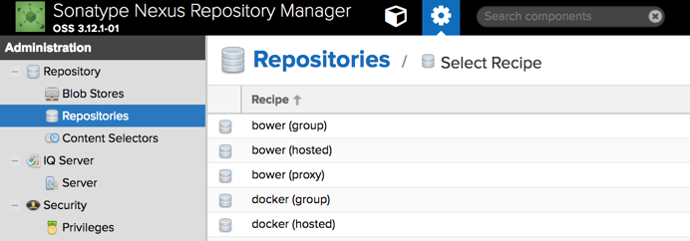

* + Uncheck the **‘Force basic authentication’** option in order to pull the image from Nexus
  + Go to Repositories - > Settings

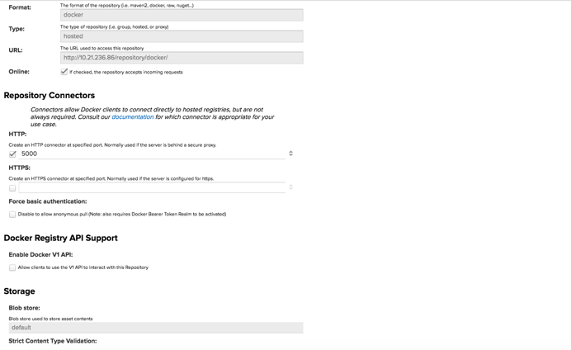

* Create Artifact Repository: In order to store the build artifacts
  + Repositories -> Create repository -> Select 'raw (hosted)' from list

### Nexus-Jenkins Setup

* Install Nexus plugin: [Nexus Artifact Uploader](https://plugins.jenkins.io/nexus-artifact-uploader), remaining changes are included in Jenkins file i.e. use the Jenkins slave and build compile image from nexus.

## Gitlab setup

### Gitlab-Jenkins Setup

* Install following plugins
  + Gitlab plugin
  + Gitlab hook
  + Gitlab merge request builder

### Configure GitLab

Create Project

* Login to gitlab
* Click on project
* Click on Create new project

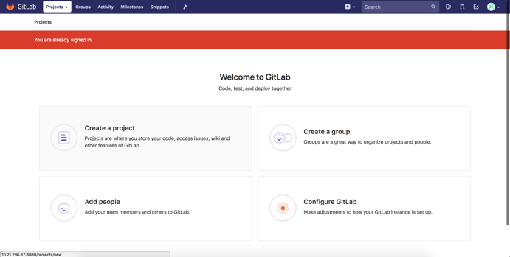

* Click on import project

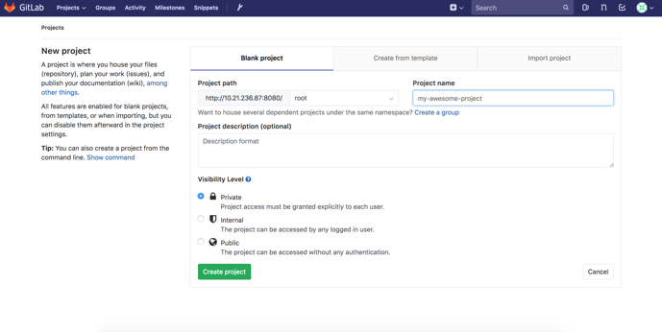

* + Click on import project
  + Click on git repo by url
  + Add git repository url
  + Click on create project
  + We can see our project in gitlab
* Settings - > access token
* There are 2 tokens
  + Once repo is updated inform Jenkins
  + Web hook token get triggered from Jenkins job
  + Check all the check boxes
  + Create personal access token
  + Token: <token>
* Go to Jenkins: Jenkins - > configure system

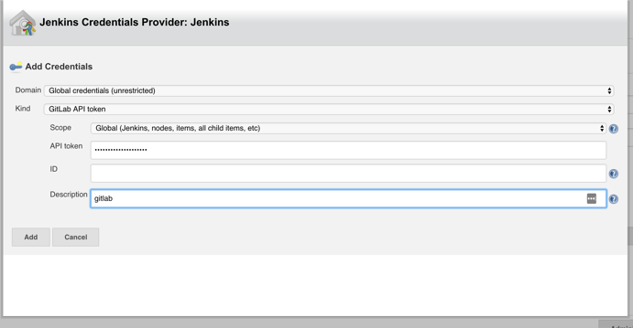

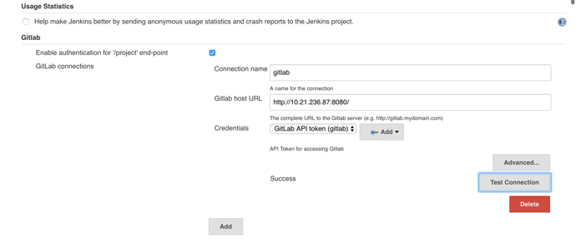

### GitLab Notify Configuration

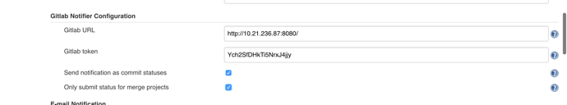

### GitLab Merge Request Builder

Jenkins Username: Jenkins-build

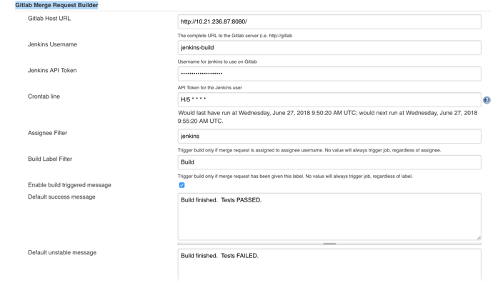

### GitLab – Jenkins, Web Hook

* As and when there is merge request in gitlab , web-hook will start the job in Jenkins.
* Jenkins setting, check the option - > Build when a change is pushed to GitLab. GitLab webhook URL: http://<jenkins ip>:8081/project/ubuntu-develop
* BuildTriggered - > Advanced -> copy the token

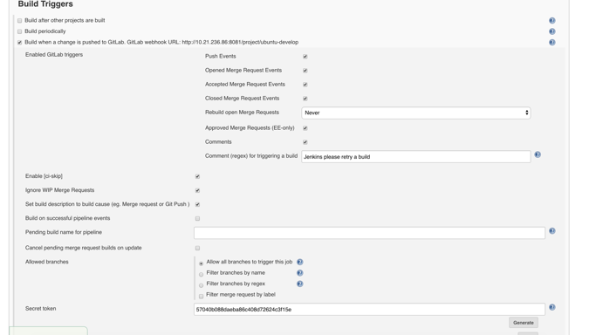

### GitLab Setting

* Select the repo

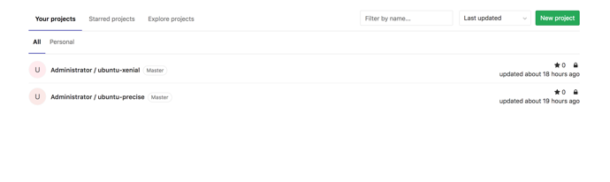

* Setting -> Integration

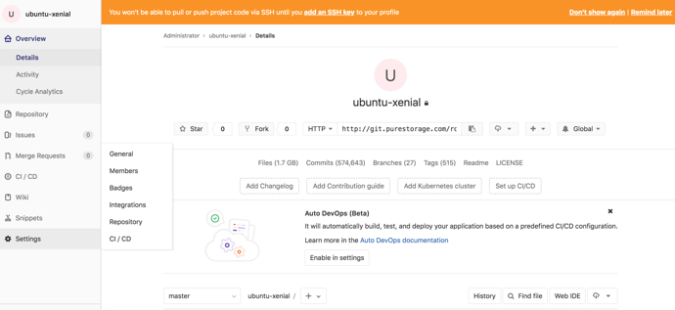

* Enter Jenkins job URL: http://<jenkins ip>:8081/project/ubuntu-develop
* Enter Token: copied from “token”
* Select - > push events and merge request check box
* Disable SSL verification

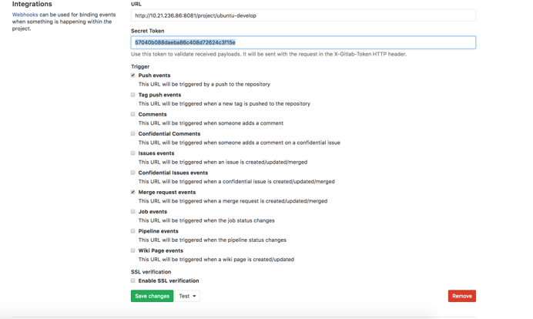

Test the Web Hook Configuration

* Click on Test - > push events

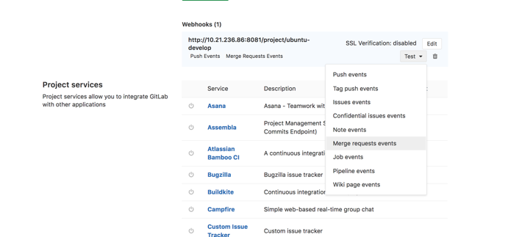

* After clicking on push events Jenkins job will start

### Web Hook Outbound Request

* go to: http://<gitlab ip>:8080/admin/application_settings
* Enable the Outbound requests

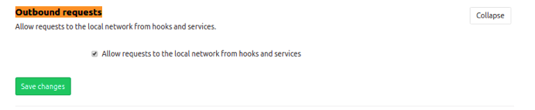

### Jenkins Workflow:

Developer ==>> Create <Feature Branch>

Developer ==>> Create PR <Feature Branch> to <develop Branch>

**JENKINS JOB <build-wordpress-dev> ->**

1. Merge <Feature Branch> to <develop> and checkout develop
2. Build project
3. Run Unit Tests
4. Create Package
5. Accept GitLab merge request on success.
6. Triggering a new build of build-wordpress-qa

**JENKINS JOB <build-worpress-qa> ->**

1. checkout develop
2. Build project
3. Run Unit Tests
4. Create Package
5. Add to Nexus artifacts
6. Publish Qunit Reports

# CI/ CD Pipeline execution

## Manual run

# **Job Name: build-kernel_Stage1**

Ubuntu-kernel Repo: git clone [git://kernel](http://git://kernel).[ubuntu.com/ubuntu/ubuntu-xenial.git](http://ubuntu.com/ubuntu/ubuntu-precise.git)

WordPress build from source, Following are the Steps to execute multiple jobs.

* + We can configure locally by cloning the repo or any node
  + Navigate to ubuntu-xenial repo
  + Run ./create-pr.sh 1 40, it will start the 40 jobs on Jenkins server
  + Monitor the performance on FlashBlade management console

# **Job Name: Pipeline build-kernel_Stage2_Stage3**

This job is parametrized wherein we can provide the KERNEL_BUILD and NO_OF_VMS to start.

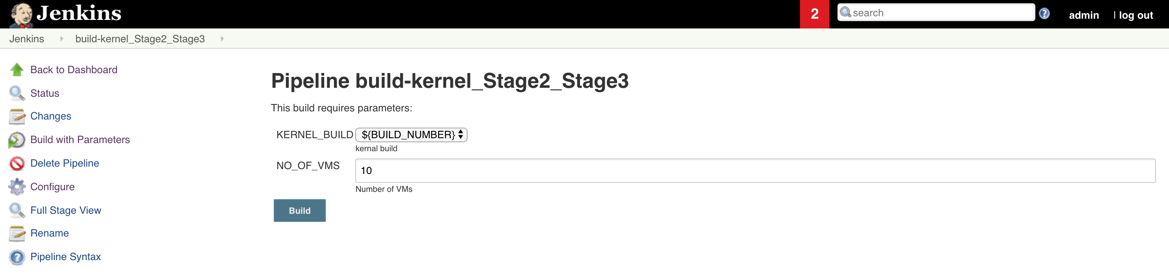

* It will install the kernel build on base VM
* Next step, it will create the clone and launch the no of vms
* On each vm startup, we are running mysql-slap utility
* Monitor the performance on FlashArray management console

# **Job Name: Pipeline build-dvd-store**

DVD Store Repo: git clone <http://10.21.236.87:8080/root/dvd-store-project>

DVD Store data creation and data load in MySQL, Following are the Steps to execute multiple jobs.

* We can configure locally by cloning the repo or any node
* Navigate to dvd-store-project repo
* Run ./create-pr.sh 1 40, it will start the 40 jobs on Jenkins server
* Monitor the performance on FlashBlade management console

# **Job Name: Pipeline build-wordpress**

WordPress Repo: git clone https://github.com/WordPress/wordpress-develop.git

WordPress build from source, Following are the Steps to execute multiple jobs.

* We can configure locally by cloning the repo or any node
* Navigate to wordpress-develop
* Run ./create-pr.sh 1 40, it will start the 40 jobs on Jenkins server
* Monitor the performance on FlashBlade management console

## Scripts

## Create PRs in multiple processes

**Setup:**

* Clone the word-press repo
* cd automation/wordpress-develop/

**Note: In case of password prompt**

* $ git config credential.helper store
* $ git push http://<gitlab ip>:8080/root/ubuntu-xenial.git
* Username: root
* Password: admin123

**Steps to execute the script:**

* Clone ubuntu-xenial Repo
* cd ~/automation/ubuntu-xenial
* git checkout develop
* git stash
* git pull
* chmod +x create-pr.sh
* ./create-pr.sh <arg1> <arg2>
* Ex: ./create-pr.sh 1 8

arg1 = Number of processes to be run in parallel.

arg2 = Number of pull request per process.

DVD-Store data for mysql

Git clone from <http://10.21.236.87:8080/root/dvd-store-project>

Steps to create data for mysql from command line:

Select ds3 folder and execute below command:

Perl Install_DVDStore.pl

This Perl script will ask the following:

* Database size as an integer (example: 20, 30,35, etc)
* Database size in MB/GB (example: MB, GB)
* Database type (User has to specify one of the following values: mssql, mysql, pgsql, or oracle)
* System OS type (User has to specify one of the following values : win (for windows) or linux (for linux)

Perl CreateConfigFile.pl

This Perl script will ask the following:

* Enter target host(s) (database/web server hostname or IP Address) (example: localhost)
* Enter database size (e.g. Input can be like 30MB, 80GB ,etc)
* Enter target hostname for perfmon CPU% display (windows only)
* Enter <username>:<password>:<IP Address> for linux machines for CPU % display (linux only)
* Enter if you want detailed view of runtime statistics of each target machine ( Y / N)

Navigate to MYSQL folder and run following command:

sh mysqlds3_create_all.sh

Wait for creating data...

# References

1. Installing Kubeadm https://kubernetes.io/docs/tasks/tools/install-kubeadm/#before-you-begin
2. Kubeadm init - <https://kubernetes.io/docs/reference/setup-tools/kubeadm/kubeadm-init/>

About the Authors

 Ashutosh Kumar -- TBD

 Abhijit Zanak

 Farida Pathan - TBD

Blog: [www.codyhosterman.com](http://www.codyhosterman.com)

Twitter: [www.twitter.com/codyhosterman](http://www.twitter.com/codyhosterman)

YouTube: <https://www.youtube.com/codyhosterman>



© 2017 Pure Storage, Inc. All rights reserved. Pure Storage, Pure1, and the P Logo are trademarks of Pure Storage, Inc. All other trademarks are the property of their respective owners.

Pure Storage, Inc.  
Twitter: @purestorage  
 [www.purestorage.com](http://www.purestorage.com/)

650 Castro Street, Suite #260   
Mountain View, CA 94041

T: 650-290-6088

F: 650-625-9667

Sales: [sales@purestorage.com](mailto:sales@purestorage.com)  
Support: [support@purestorage.com](mailto:support@purestorage.com)  
Media: [pr@purestorage.com](mailto:pr@purestorage.com)  
General: [info@purestorage.com](mailto:info@purestorage.com)